GET STARTED WITH HOOPLA DIGITAL – Electronic book, audiobooks, movies, and music
From a Computer -- Go to https://hoopladigital.com
- Click “GET STARTED TODAY” (toward the center of the page)
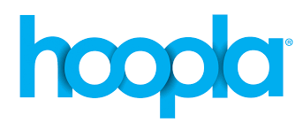
- Follow the prompts to create an account
**please type Davis Public Library instead of 03464
- Log In & enjoy!
From a Phone
- Install the App from the Apple or Google Play Store
- Open it & “Sign Up” (if you didn’t already from your phone)
- Log In & Enjoy!
GET STARTED WITH RB DIGITAL – Audiobooks and Streaming of Entertainment & Education
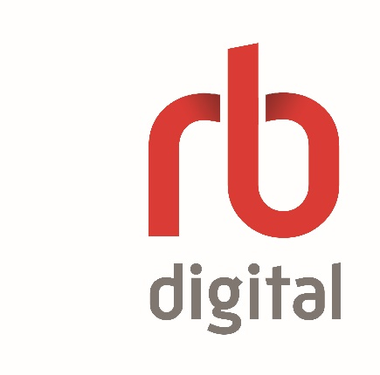
From a Computer -- Go to https://davisnh.rbdigital.com
- Click “REGISTER” (top right of the page)
- Fill in the information to create an account & Log in
From a Phone
- Install the RBDigital App
- Open it and click “Sign Up” –or--
- Sign In if you already created the account on a computer
GET STARTED WITH LIBBY– Electronic audiobooks, books, and magazines
From a Computer
- Go to https://nh.overdrive.com/
- Click “Sign In” (top right of the page)
- Select our library and enter your card number and PIN (AKA Password)
From a Phone
- Install the Libby App
- Open it and follow the prompts to add the Davis Library and your card
- Search for books! Click “Library” at the bottom left of the screen and type near the
A few notes…
**If you need your card number or PIN (usually the last 4 digits of your pone number), please email davispubliclibrary@gmail.com (or call 603-446-6251 during curbside pickup, Tu 10-12, W & F 4-6).
** After creating an account in any system, and before you start searching, please make sure you are actually logged in! Sometimes you still have to log in after creating the account.

